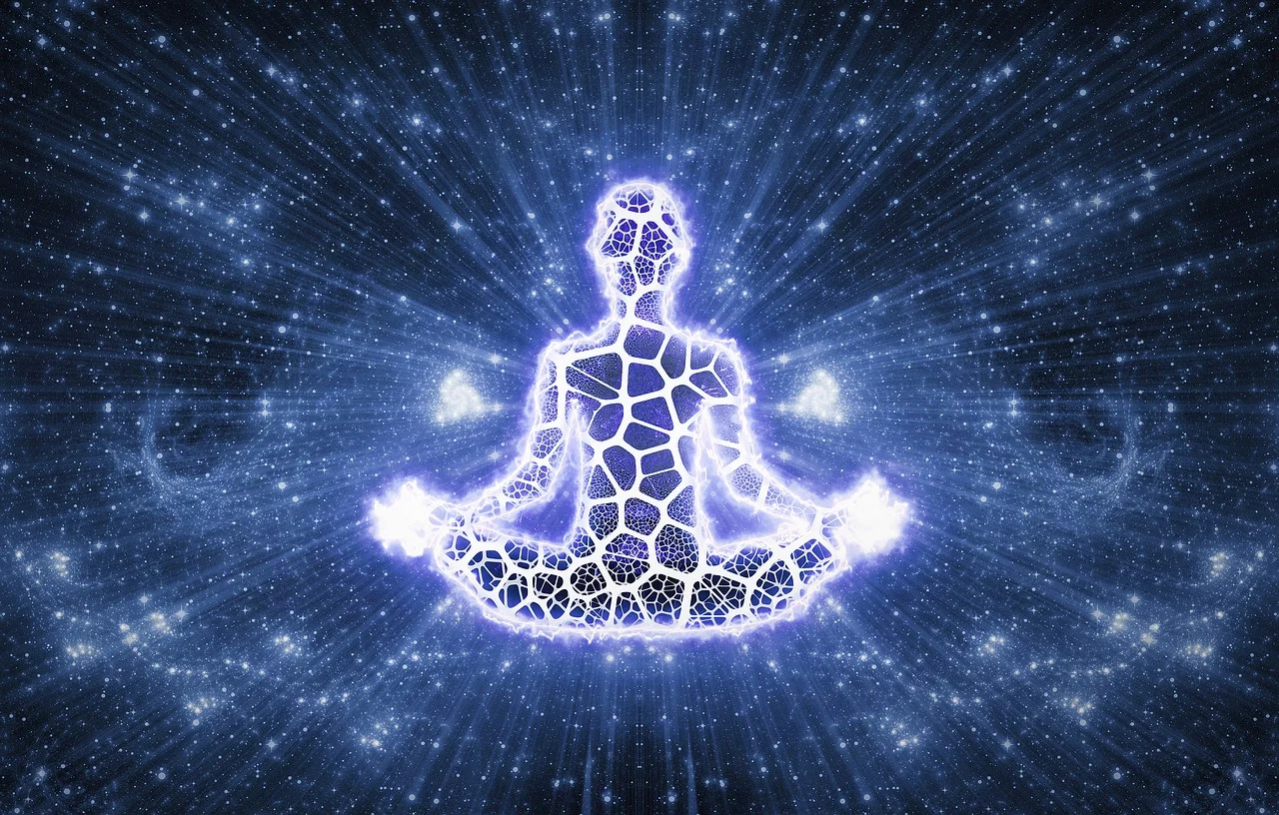

Meditation May Help Us
By Xavier Bankhead
Winston-Salem, North Carolina- Meditation is a powerful ancient practice that is needed now more than ever. Meditation has been proved to help calm the mind, reduce negative emotions, and increase self-awareness In a world full of civil and emotional unrest and chaos, meditation is needed now more than ever.
Meditation is an ancient Eastern practice that allows the practitioner to reach a mental state of “now”. Scattering thoughts and ideas are released and then brought back to a state of “now”. Constantly doing this practice increases concentration, helps manage stress and anxiety, fights addiction, and promotes altruistic behavior. According to the Mayo Clinic, some research suggests that meditation may help people manage symptoms of conditions such as anxiety, cancer, depression, high blood pressure, and many more severe and chronic illnesses. (Mayo, Clinic, 2020)
There are countless stories of how meditation has helped people all across the world with a variety of issues. Let’s take a look at a couple of meditation stories. Mary, a Texas native, shares how meditation helped cured her chronic insomnia.
“I cannot say for certain what one specific thing made meditation work for me. I think I was just so desperate to find a solution to relearn how to sleep and calm down. I had faith that because so many people were doing it, it would work for me—and it has done so, beautifully. Learning to meditate has cured me of eight years of chronic insomnia for which I used to take Ambien, which I now no longer need.”(Aaptiv, 2019)

Lastly, we have Wendy. Wendy had this to say when describing how meditation solved her binge-eating problem.

“I used to think meditation was for yogis and bearded men who wear dresses. It wasn’t until I realized that meditating could solve my binge eating that I decided to try it. I heard that willpower is like a muscle and could be strengthened through meditation. The first time I tried was a disaster. I would start meditating and within three seconds be thinking about what I was going to make for dinner. It took practice, but now I love it! Like a muscle, willpower can grow, but it can also be fatigued. If willpower is like a cell phone battery, meditation is what charges it back up.” (Aaptiv, 2019)

Meditation is an ancient Eastern practice that allows one to calm the mind, reduce negative emotions, and increase self-awareness. As detailed earlier, meditation is powerful. It has and can change one’s life. Nowadays, there is a lot of unease and stress. People are emotional, in pain, suffering. Meditation may be a gateway into easing that stress. No one is saying it can cure world hunger, but it may help. Which is what we all need every now and then.

Short Bio
Xavier Bankhead is a 20-year-old North Carolina A&T State University student, currently studying Public Relations. Xavier was born and raised in Winston,Salem, North Carolina and seeks to use his knowledge to manifest his dreams and live a satisfying life.

Works Cited
Tigar, Lindsay. “10 People Share Their Meditation Stories.” Aaptiv, Aaptiv, 10 July 2019, aaptiv.com/magazine/meditation-stories.
“A Beginner's Guide to Meditation.” Mayo Clinic, Mayo Foundation for Medical Education and Research, 22 Apr. 2020, www.mayoclinic.org/tests-procedures/meditation/in-depth/meditation/art-20045858.

